**Milestone 3**

**Team – Health Analyst’s**

We are a group of 5, so we have each individually chosen a direction and are working on it.

I have given our draft visualizations for only 2 directions, while our other directions are still in their beginning of drafting stage.

**Timeseries Direction:**

**(a)**

We are exploring the relationship between the date of admission, Discharge Date and an additional variable Length of Stay. With this we can identify any patterns or trends over time. For our final visualizations, we plan to do at least 2 of the following in this direction:

1. One of our visualizations is a calendar heat map that displays the count of admissions for each day, with lighter shades indicating higher admission counts.
2. A tile plot to visualize the distribution of length of hospital stay (calculated by subtracting Date of Admission from Discharge Date) across different Medical Conditions. This could help identify conditions that tend to require longer hospital stays.
3. line graph with smoothing to visualize the trend of length of hospital stay over time (by year and month), broken down by Insurance Provider. This could help identify if certain insurance providers tend to have longer or shorter hospital stays for their patients.

**(b)**

1. Calendar Heat Map

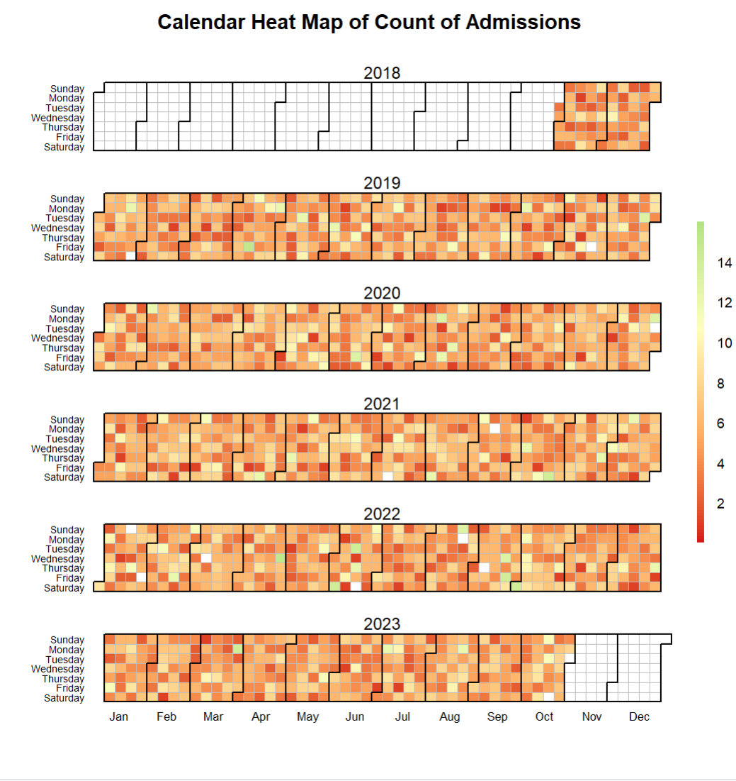

A Calendar Heat Map over the period of 4 Years. We have used a Divergent Color Scale but we soon plan to change the color scheme so that the admission trend may be visible. If possible, we would also enhance the calendar heat map by adding additional variables like Admission type and Test results to identify relationships and factors affecting admission counts over time.

2. Tile plot

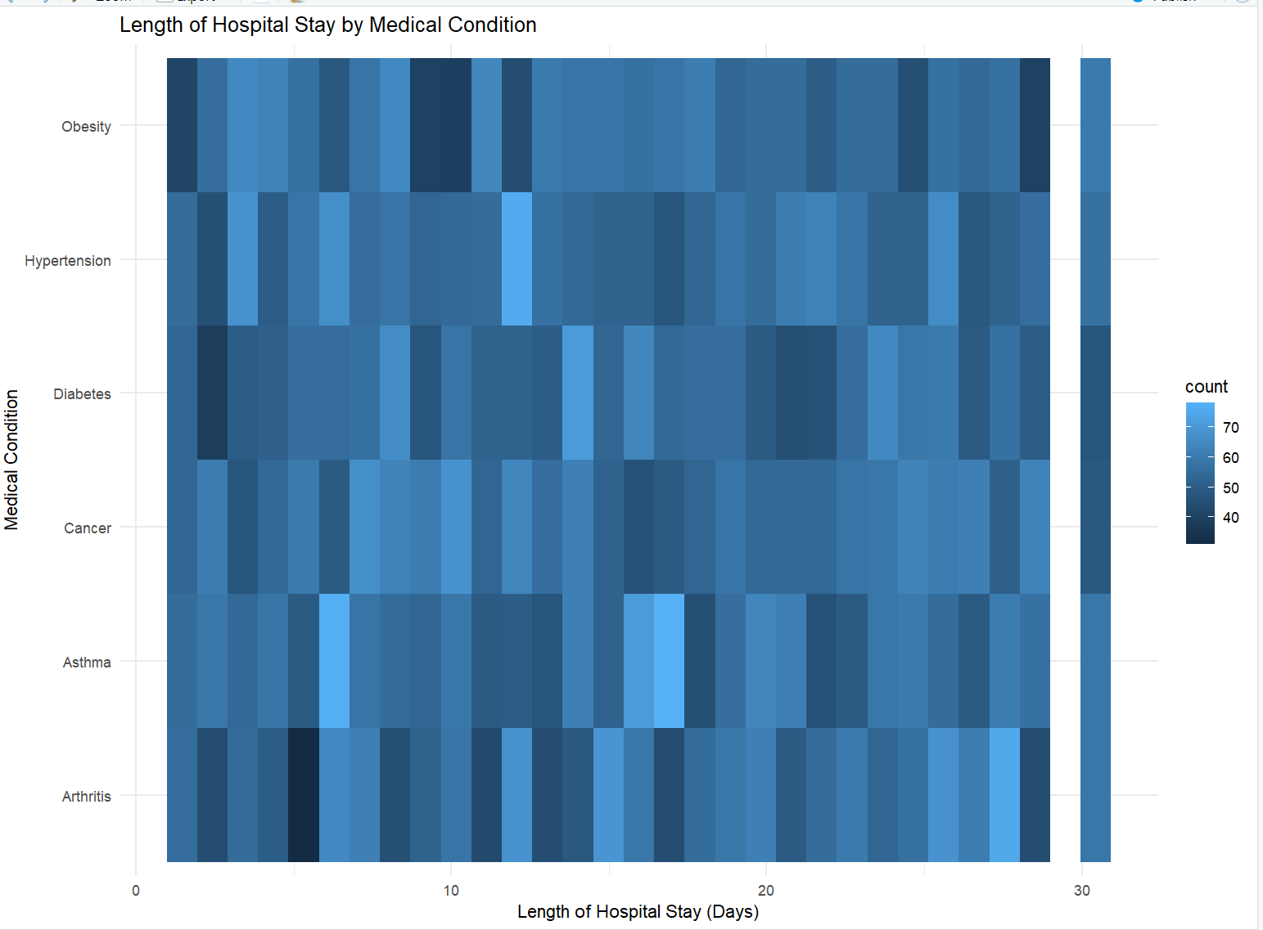

This is just one of the drafts for tile plot but we will further enhance the tile plot so that it could we give a good explanatory visualization.

3. Smoothing Line graph

We plan to do a smoothing line graph with the Length of stay and Insurance provider variable. We are yet to get a draft for this graph but will try to work on it.

**Age Distribution Direction:**

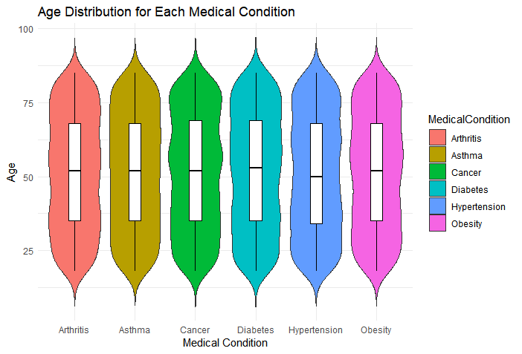

Explanation:

The above visualization represents various medical condition that patients suffer from, and these conditions are visualized with respect to different age groups ranging from 30-80. From the visualization we can say that the mean age group where a person with all conditions is in their 50s

Even if we may see trends and draw conclusions about the age distribution of certain medical conditions, these findings still need more research to identify risk factors or underlying causes.

We will also continue to explore different relationships with respect to the age groups in this direction.

**Financial Direction:**

One of the visualizations we will work on aims to analyze the distribution of billing amounts across different medical conditions, providing insights into the cost implications associated with various health conditions in the dataset. We aim to identify patterns and trends that may inform healthcare decision-making and resource allocation strategies by comparing the average billing amounts for each medical condition. Additionally, this visualization seeks to highlight any significant variations in billing amounts between different medical conditions.

**Medical Records Related Direction:**

We will be working in this direction by visualizing medical condition and their admission type and the type of medication being provided. One of the visualization will also include mapping of relationships between medical conditions, their corresponding admission types and the specific medication administered. By doing this, we aim to uncover insights into how different health issues are approached and treated within the healthcare system based on their urgency. This analysis will enable us to discover patterns regarding the medication being provided as well.